CSCI 3410 Database Systems
Assignment 4
Due: Sunday, March 13 2016 before 11:59 PM
Requirements
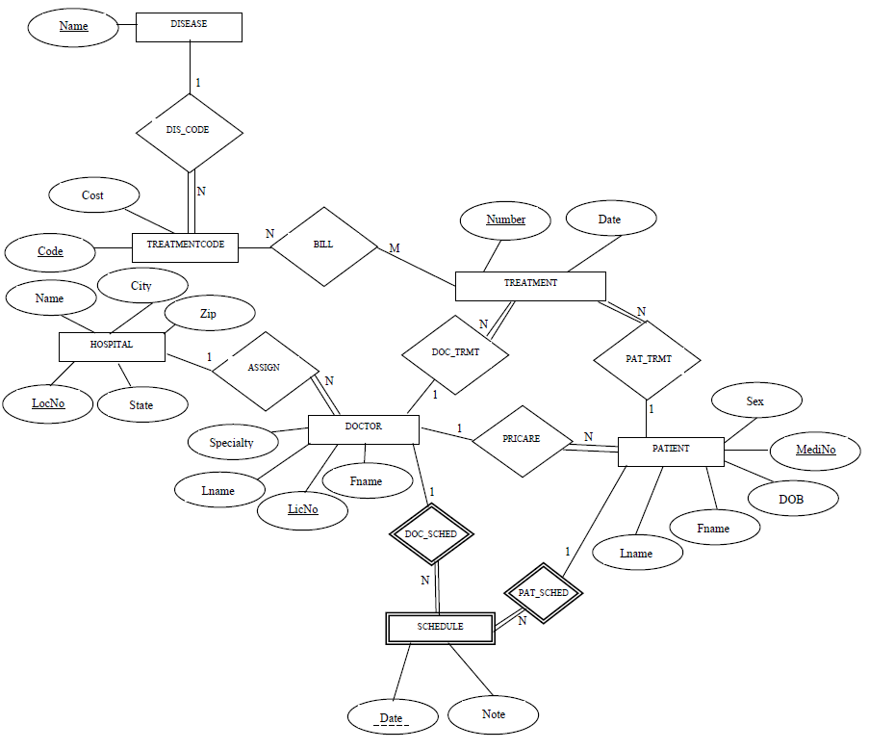

Convert the above ER model for the Augusta University Health System to a relational model using the 7 step algorithm (in Section 9.1). The relational model should be of the format R(A₁, A₂, A₃,…A_{n}).
Submit a word document containing your model.

Other Requirements
1. Your submitted document must contain a header (at the top) similar to the one bellow:
NAME:
ASSIGNMENT: (assignment number)
DUE DATE:

2. Submitted document should be neatly typed and uniformly formatted.
2. Do NOT include jokes, funny or other inappropriate remarks anywhere in your document. Any of such will incur a zero grade for this assignment.
3. The file name for your document should be as follows: firstname_lastname_hw#.doc (e.g. Onyeka_Ezenwoye_hw1.doc, only submit word documents)
4. Submit (one) file as attachment to the course page in D2L.

